K NARENDRA-192321162

1. Illustrate the concept of inter-process communication using message queue with a C program.

# Aim:

To implement inter-process communication (IPC) using message queues in C.

# Algorithm:

* 1. Create a message queue using msgget().
  2. Send a message to the queue using msgsnd().
  3. Receive the message from the queue using msgrcv().
  4. Display the received message.
  5. Terminate the processes and clean up the resources.

# Procedure:

1. Create a message queue with a unique key.
2. Define a structure for the message.
3. Use msgsnd() in the sender process to send a message to the queue.
4. Use msgrcv() in the receiver process to read the message from the queue.
5. Display the received message.
6. Clean up by removing the message queue when no longer needed. CODE:

#include <stdio.h> #include <sys/ipc.h>

#include <sys/msg.h> #include <string.h>

#define MSG_SIZE 1024

struct msg_buffer { long msg_type;

char msg_text[MSG_SIZE];

};

int main() {

key_t key = 1234; int msgid;

struct msg_buffer message;

msgid = msgget(key, 0666 | IPC_CREAT); message.msg_type = 1;

printf("Enter a message: ");

fgets(message.msg_text, MSG_SIZE, stdin); msgsnd(msgid, &message, sizeof(message), 0); printf("Message sent to the queue.\n");

return 0;

} OUTPUT:

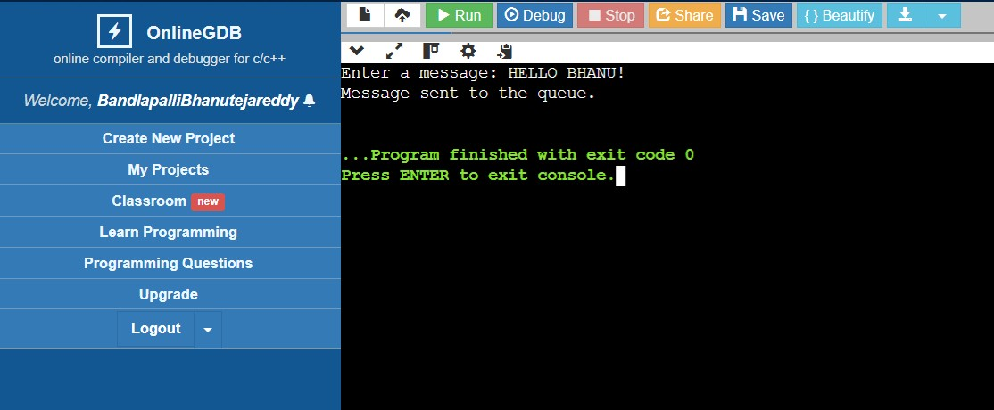

# Result:

The C program successfully demonstrates inter-process communication using message queues. The sender process sends a message to the message queue, and the receiver process retrieves and displays the message from the queue.